History and Approaches (2-4%)
AP Psychology Study Guide
- Psychology is derived from physiology (biology) and philosophy
- Early Approaches
  - Structuralism – used INTROSPECTION (act of looking inward to examine mental experience) to determine the underlying STRUCTURES of the mind
  - Functionalism – need to analyze the PURPOSE of behavior
- Approaches Key Words
  - Evolutionary – Genes
  - Humanistic – free will, choice, ideal, actualization
  - Biological – Brain, NTs
  - Cognitive – Perceptions, thoughts
  - Behavioral – learned, reinforced
  - Psychoanalytic/dynamic – unconscious, childhood
  - Sociocultural – society
  - Biopsychosocial – combo of above
- People:
  - Mary Calkins: First Fem. Pres. of APA
  - Charles Darwin: Natural selection & evolution
  - Dorothea Dix: Reformed mental institutions in U.S.
  - Stanley Hall: 1st pres. of APA1st journal
  - William James: Father of American Psychology – functionalist
  - Wilhem Wundt: Father of Modern Psychology – structuralist
  - Margaret Floy Washburn–1st fem. PhD
  - Christine Ladd Franklin – 1st fem.
Research Methods
(8-10%)
- Experiment : Adv: researcher controls variables to establish cause and effect Disadv: difficult to generalize
  - Independent Variable: manipulated by the researcher
    - Experimental Group: received the treatment (part of the IV)
    - Control Group: placebo, baseline (part of the IV)
    - Placebo Effect: show behaviors associated with the exp. group when having received placebo
    - Double-Blind: Exp. where neither the participant or the experimenter are aware of which condition people are assigned to
  - Dependent Variable: measured variable (is DEPENDENT on the independent variable)
- Operational Definition: clear, precise, typically quantifiable definition of your variables – allows replication
- Confound: error/ flaw in study

- Random Assignment: assigns participants to either control or experimental group at random – minimizes bias, increase chance of equal representation
- Random Sample: method for choosing participants – minimizes bias
- Validity: accurate results
- Reliability: same results every time
- Naturalistic Observation: Adv: real world validity (observe people in their own setting) Disadv: No cause and effect
- Correlation: Adv: identify relationship between two variables Disadv: No cause and effect (CORRELATION DOES NOT EQUAL CAUSATION)
  - Positive Correlation – Variables vary in the same direction
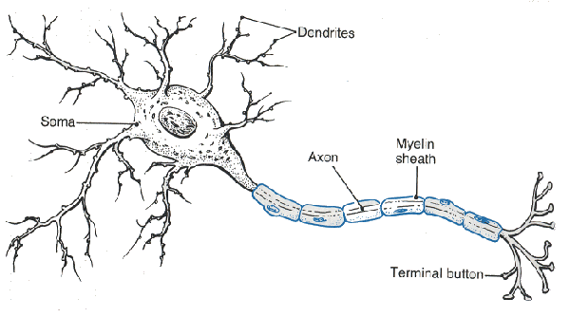
  - Negative Correlation – variables vary in opposite directions
  - The stronger the # the stronger the relationship REGARDLESS of the pos/neg sign
- Case Study: Adv. Studies ONE person (usually) in great detail – lots of info Disadv: No cause and effect
- Descriptive stats:shape of the data
  - Measures of Central Tendency:
    - Mean: Average (use in normal distribution)
    - Median: Middle # (use in skewed distribution)
    - Mode: occurs most often

- Inferential statistics: establishes significance (meaningfulness) Significant results = NOT due to chance
- Ethical Guidelines (APA)
  - Confidentiality
  - Informed Consent
  - Debriefing
  - Deception must be warranted
Biological Basis
(8-10%)
- Neuron: Basic cell of the NS
  - Dendrites: Receive incoming signal
  - Soma: Cell body (includes nucleus)
  - Axon: AP travels down this
  - Myelin Sheath: speeds up signal down axon
  - Terminals: release NTs – send signal onto next neuron
  - Synapse: gap b/w neurons
- Action Potential: movement of sodium and potassium ions across a membrane sends an electrical charge down the axon
  - All or none law: stimulus must trigger the AP past its threshold, but does not increase the intensity of the response (flush the toilet)
  - Refractory period: neuron must rest and reset before it can send another AP (toilet resets)
- Sensory neurons – receive signals
- Afferent neurons – Accept signals
- Motor neurons – send signals
- Efferent neurons – signal Exits
- Central NS: Brain and spinal cord
- Peripheral NS: Rest of the NS
  - Somatic NS: Voluntary movement
  - Autonomic NS: Involuntary (heart, lungs, etc)
    - Sympathetic NS: Arouses the body for fight/flight (generally activates)
    - Parasympathetic NS: established homeostasis after a sympathetic response (generally inhibits)
- Neurotransmitters (NTs): Chemicals released in synaptic gap, received by neurons
  - GABA: Major inhibitory NT
  - GlutamatE: Major Excitatory NT
  - Dopamine: Reward & movement
  - Serotonin: Moods and emotion
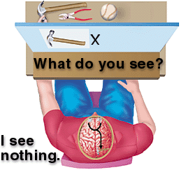
  - Acetylcholine (ACh): Memory
  - Epinephrine & Norepinephrine: sympathetic NS arousal
  - Endorphins: pain control, happiness
  - Oxytocin: love and bonding
- Agonist: drug that mimics a NT
- Antagonist: drug that blocks a NT
- Reuptake: Unused NTs are taken back up into the sending neuron. SSRIs (selective serotonin reuptake inhibitors) block reuptake – treatment for depression
- Areas of the Brain:
- Hindbrain: oldest part of the brain
  - Cerebellum – movement (what does it take to ring a bell)
  - Medulla – vital organs (HR, BP)
  - Pons – sleep/arousal (Ponzzzzzz)
- Midbrain
  - Reticular formation: attention (if you can’t pay attention, You R F’d)
- Forebrain: higher thought processes
  - Limbic System
    - Amygdala: emotions, fear (Amy, da! You’re so emotional!)
    - Hippocampus: memory (if you saw a hippo on campus you’d remember it!)
  - Thalamus: relay center
  - Hypothalamus: Reward/pleasure center, eating behaviors
  - Broca’s Area: Inability to produce speech (Broca – Broken speech)
  - Wernicke’s Area: Inability to comprehend speech (Wernicke’s what?)
  - Cerebral Cortex: outer portion of the brain – higher order thought processes
    - Occipital Lobe: located in the back of the head - vision
    - Frontal Lobe: decision making, planning, judgment, movement, personality
    - Parietal Lobe: located on the top of the head - sensations
    - Temporal Lobe: located on the sides of the head (temples) – hearing and face recognition
    - Somatosensory Cortex: map of our sensory receptors –in parietal lobe
    - Motor Cortex: map of our motor receptors – located in frontal lobe
  - Corpus Callosum: bundle of nerves that connects the 2 hemispheres – sometimes severed in patients with severe seizures – leads to “split-brain patients”
    - Lateralization: the brain has some specialized features – language is processed in the L Hemisphere
    - Split-brain experiments: done by Sperry & Gazzanaga.
    - Images shown to the right hemisphere will be processed in the left (& vice versa), patient can verbally identify what they saw
- Brain Plasticity: Brain can “heal” itself
- Nature vs. Nurture: Answer is both
  - Twin Studies:
    - Identical twins – Monozygotic (MZ)
    - Fraternal twins – Dizygotics (DZ)
  - Genetics: MZ twins will have a higher percentage of also developing a disease
  - Environment: MZ twins raised in different environments show differences
- Endocrine System: sends hormones throughout the body
  - Pituitary Gland: Controlled by hypothalamus. release growth hormones
  - Adrenal Glands: related to sympathetic NS: releases adrenaline
Sensation & Perception
(6 – 8%)
- Absolute Threshold: detection of signal 50% of time (is it there)
- Difference Threshold (also called a just noticeable difference (JND) and follows WEBER’S LAW: two stimuli must differ by a constant minimum proportion. (Can you tell a change?)
- Signal Detection Theory
- Sensory Adaptation: diminished sensitivity as a result of constant stimulation (can you feel your underwear?)
- Perceptual Set: tendency to see something as part of a group – speeds up signal processing
- Inattentional Blindness: failure to notice something b/c you’re so focused on another task (gorilla video)
- Cocktail party effect: notice your name across the room when its spoken, when you weren’t previously paying attention
- Visual System:
  - Pathway of vision: light cornea pupil/iris lens retina rods/cones bipolar cells ganglion cells optic nerve optic chiasm occipital lobe
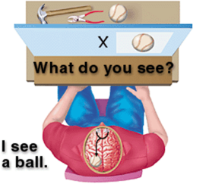
  - Cornea – protects the eye
  - Pupil/iris – controls amount of light entering eye
  - Lens – focuses light on retina
  - Fovea–area of best vision(cones here)
  - Rods – black/white, dim light
  - Cones – color, bright light
  - Bipolar cells – connect rods/cones and ganglion cells
  - Ganglion cells – opponent-processing occurs here
  - Blind spot – occurs where the optic nerve leaves the eye
  - Feature detectors – specialized cells that see motion, shapes, lines, etc. (experiments by Hubel & Weisel)
- Theories of color vision:
  - Trichromatic – three cones for receiving color (blue, red, green)
    - Explains color blindness - they are missing a cone type
  - Opponent Process – complementary colors are processed in ganglion cells – explains why we see an after image
- Visual Capture: Visual system overwhelms all others (nauseous in an IMAX theater – vision trumps vestibular)
- Constancies: recognize that objects do not physically change despite changes in sensory input (size, shape, brightness)
- Phi Phenomenon: adjacent lights blink on/off in succession – looks like movement (traffic signs with arrows)
- Stroboscopic movement: motion produced by a rapid succession of slightly varying images (animations)
- Monocular Cues (how we form a 3D image from a 2D image)
  - Interposition: overlapping images appear closer
  - Relative Size: 2 objects that are usually similar in size, the smaller one is further away
  - Relative Clarity: hazy objects appear further away
  - Texture Gradient: coarser objects are closer
  - Relative Height: things higher in our field of vision look further away
  - Linear Perspective: parallel lines converge with distance (think railroad tracks)
- BINOCULAR CUES: (how both eyes make up a 3D image)
  - Retinal Disparity: Image is cast slightly different on each retinal, location of image helps us determine depth
  - Convergence: Eyes strain more (looking inward) as objects draw nearer
- TOP-DOWN PROCESSING: Whole smaller parts
- BOTTOM-UP PROCESSING: Smaller Parts Whole
- Auditory System:
  - Pathway of sound: sound pinna auditory canal ear drum (tympanic membrane) hammer, anvil, stirrup (HAS) oval window cochlea auditory nerve temporal lobes
  - Outer Ear: pinna (ear), auditory canal
  - Middle Ear: ear drum , HAS (bones vibrate to send signal)
  - Inner Ear: cochlea – like COCHELLA (sounds 1st processed here)
- Theories of hearing: both occur in the cochlea
  - Place theory – location where hair cells bends determines sound (high pitches)
  - Frequency theory – rate at which action potentials are sent determines sound (low pitches)
- Other Senses:
  - Touch: Mechanoreceptors spinal cord thalamus somatosensory cortex
  - Pain: Gate-control theory: we have a “gate” to control how much pain ix experienced
  - Kinesthetic: Sense of body position
  - Vestibular: Sense of balance (semicircular canals in the inner ear effect this)
  - Taste (gustation): 5 taste receptors: bitter, salty, sweet, sour, umami (savory)
  - Smell (olfaction): Only sense that does NOT route through the thalamus 1st. Goes to temporal lobe and amygdala
- Gestalt Psychology: Whole is greater than the sum of its parts
  - Gestalt Principles:
    - Figure/ground: organize information into figures objects (figures) that stand apart from surrounds (back ground)
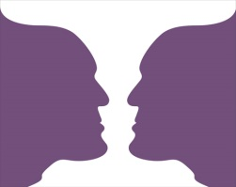
    - Closure: tendency to mentally fill in gaps
    - Proximity: tendency to group things together that appear near each other
    - Similarity: tendency to group things together based off of looks
    - Continuity: tendency to mentally form a continuous line
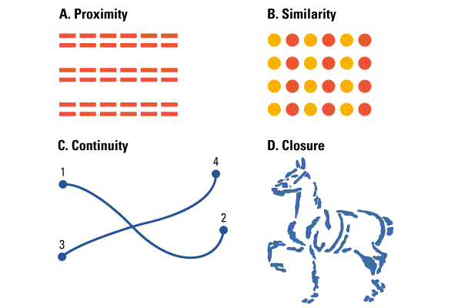

States of Consciousness (2 – 4%)
- STATES of CONSCIOUSNESS:
  - Higher-Level: controlled processes – totally aware
  - Lower-Level: automatic processing (daydreaming, phone numbers)
  - Altered States: produced through drugs, fatigue, hypnosis
  - Subconscious: Sleeping and dreaming
  - No awareness: Knocked out
- METACOGNITION: Thinking about thinking
- SLEEP:
  - Beta Waves: awake
  - Alpha Waves: high amp., drowsy
  - Stage 1: light sleep
  - Stage 2: bursts of sleep spindles
  - Stage 3 (delta waves: Deep sleep
  - Stage 4: extremely deep sleep
  - Rapid Eye Movement (REM): dreaming
Entire cycle takes 90 minutes, REM occurs inb/w each cycle. REM lasts longer throughout the night
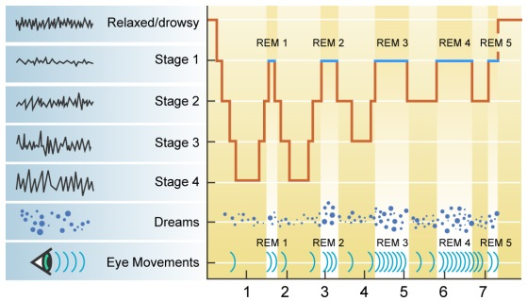
- CIRCADIAN RHYTHM: 24 hour biological clock
  - Body temp and awareness change due to this
  - Controlled by the Suprachiasmatic nucleus (SCN) in the brain
  - Explains jet lag
- SLEEP DISORDERS
  - Insomnia: Inability to fall asleep (due to stress/anxiety)
  - Sleep walking: (due to fatigue, drugs, alcohol)
  - Night terrors: extreme nightmares – NOT in REM sleep – typical in children
  - Narcolepsy: fall asleep out of nowhere (due to deficiency in orexin)
  - Sleep Apnea: stop breathing suddenly while asleep (due to obesity usually)
- DREAM THEORIES:
  - Freud’s Unconscious Wish Fulfillment: Dreaming is gratification of unconscious desires and needs
    - Latent Content: hidden meaning of dreams
    - Manifest Content: obvious storyline of dream
- Activation Synthesis: Brain produces random bursts of energy – stimulating lodged memories. Dreams start random then develop meaning
- HYPNOSIS
  - It Can: Reduce pain, help you relax
  - It CANNOT: give you superhuman strength, make you regress, make you do things against your will
- PSYCHOACTIVE DRUGS:
  - Triggers dopamine release in the brain
  - Depressants: Alcohol, barbiturates, tranquilizers, opiates (narcotics)
    - Decrease sympathetic NS activation, highly addictive
  - Stimulants: Amphetamines, Cocaine, MDMA (ecstasy), Caffeine, Nicotine
    - Increase sympathetic NS activation, highly addictive
  - Hallucinogens: LSD, Marijuana
    - Causes hallucinations, not very addictive
  - Tolerance: Needing more of a drug to achieve the same effects
  - Dependence: Become addicted to the drug – must have it to avoid withdrawal symptoms
  - Withdrawal: Psychological and physiological symptoms associated with sudden stoppage. Unpleasant – can kill you.
Learning
(7-9 %)
- CLASSICAL CONDITIONING: PAVLOV!
  - Unconditioned Stimulus (US): brings about response w/o needing to be learned (food)
  - Unconditioned Response (UR): response that naturally occurs w/o training (salivate)
  - Neutral Response (NS): stimulus that normally doesn’t evoke a response (bell)
  - Conditioned Stimulus (CS): once neutral stimulus that now brings about a response (bell)
  - Conditioned Response (CR): response that, after conditioning, follows a CS (salivate)
  - Contiguity: Timing of the pairing, NS/CS must be presented immediately BEFORE the US
  - Acquisition: process of learning the response pairing
  - Extinction: previously conditioned response dies out over time
  - Spontaneous Recovery: After a period of time the CR comes back out of nowhere
  - Generalization: CR to like stimuli (similar sounding bell)
  - Discrimination: CR to ONLY the CS
- Contingency Model: Rescorla & Wagner – classical conditioning involves cognitive processes
- CONDITIONED TASTE AVERSION (ONE-TRIAL LEARNING): John Garcia – Innate predispositions can allow classical conditioning to occur in one trial (food poisoning)
- COUNTERCONDITIONING: Little Albert and John Watson (father of behaviorism) – conditioned a fear in a baby (only to countercondition – remove it- later on)
- OPERANT CONDITIONING: SKINNER!
  - lAW OF EFFECT (thorndike): Behaviors followed by pos. outcomes are strengthened, neg. outcomes weaken a behavior (cat in the puzzle box)
- PRINCIPLES OF OPERANT cOND:
  - Pos. Reinforcement: Add something nice to increase a behavior (gold star for turning in HW)
  - Neg. Reinforcement: Take away something bad/annoying to increase a behavior (put on seatbelt to take away annoying car signal)
  - Pos. Punishment: Add something bad to decrease a behavior (spanking)
  - Neg. Punishment: Take away something good to decrease a behavior (take away car keys)
  - Primary Reinforcers: innately satisfying (food and water)
  - Secondary Reinforcers: everything else (stickers, high-fives)
    - Token Reinforcer: type of secondary- can be exchanged for other stuff (game tokens or money)
  - Generalization: respond to similar stimulus for reward
  - Discrimination: stimulus signals when behavior will or will not be reinforced (light on means response are accepted)
  - Extinction / Spontaneous Recovery: same as classical conditioning
  - Premack Principle: high probability activities reinforce low probability activities (get extra min at recess if you everyone turns in their HW)
  - Overjustification Effect: reinforcing behaviors that are intrinsically motivating causes you to stop doing them (give a child 5$ for reading when they already like to read – they stop reading)
  - Shaping: use successive approximations to train behavior (reward desired behaviors to teach a response – rat basketball)
  - Chaining: tie together several behaviors

  - Continuous Reinforcement schedule: Receive reward for every response
  - Fixed Ratio schedule: Reward every X number of response (every 10 envelopes stuffed get $$)
  - Fixed Interval schedule: Reward every X amount of time passed (every 2 weeks get a paycheck)
  - Variable Ratio schedule: Rewarded after a random number of responses (slot machine
  - Variable Interval schedule: Rewarded after a random amount of time has passed (fishing)
  - Variable schedules are most resistant to extinction (how long will keep playing a slot machine before you think its broken?)
- SOcial (observational) learning: Bandura!
- Modeling Behaviors: Children model (imitate) behaviors. Study used BoBo dolls to demonstrate the following
  - Prosocial – helping behaviors
  - Antisocial – mean behaviors
- MISC LEARNING TYPES
  - Latent learning (Tolman!) – learning is hidden until useful (rats in maze get reinforced half way through, performance improved
    - Cognitive maps – mental representation of an area, allows navigation if blocked
  - Insight learning (Kohler!) – some learning is through simple intuition (chimps with crates to get bananas)
  - Learned Helplessness (Seligman!) – no matter what you do you never get a positive outcome so you just give up (word scrambles)
cognition
(8 – 10%)
ENCODING: Getting info into memory
- Automatic encoding – requires no effort (what did you have for breakfast?)
- Effortful encoding – requires attention (school work)
- Shallow, intermediate, deep processing: the more emphasis on MEANING the deeper the processing, and the better remembered
- Imagery – attaching images to information makes it easier to remember (shoe w/ spaghetti laces)
- Self-referent encoding – we better remember what we’re interested in (you’d remember someone’s phone number who you found extremely attractive)
- Dual encoding – combining different types of encoding aids in memory
- Chunking – break info into smaller units to aid in memory (like a phone #)
- Mnemonics – shortcuts to help us remember info easier
  - Acronyms – using letter to remember something (PEMDAS)
  - Method of loci – using locations to remember a list of items in order
- Context dependent memory – where you learn the info you best remember the info (scuba divers testing)
- State dependent memory – the physical state you were in when learning is the way you should be when testing (study high, test high)
STORAGE: Retaining info over time
- Information Processing Model – Sensory memory, short term memory, long term memory model
- Sensory Memory – stores all incoming stimuli that you receive (first you have to a pay attention)
  - Iconic Memory – visual memory, lasts 0.3 seconds
  - Echoic Memory – auditory memory, lasts 2-3 seconds
- Short Term Memory – info passes from sensory memory to STM – lasts 30 secs, and can remember 7 ± 2 items
  - Rehearsal (repeating the info) resets the clock
- Working Memory Model splits STM into 2 – visual spatial memory (from iconic mem) and phonological loop (from echoic mem). A “central executive” puts it together before passing it to LTM
- Long term memory – lasts a life time
  - Explicit (Declarative): Conscious recollection
    - Episodic: events
    - Semantic: facts
  - Implicit (Nondeclarative): unconscious recollection
    - Classical conditioning
    - Priming: info that is seen earlier “primes” you to remember something later on (octopus, assassin, climate, bogeyman)
    - Procedural: skills
- Memory organization
  - Hierarchies: memory is stored according to a hierarchy
  - Semantic networks: linked memories are stored together
  - Schemas: preexisting mental concept of how something should look (like a restaurant)
- Memory storage
  - Acetylcholine neurons in the hippocampus for most memories
  - Cerebellum for procedural memories

  - Long-term potentiation: neural basis of memory – connections are strengthened over time with repeated stimulation (more firing of neurons)
RETRIEVAL: Taking info out of storage
- Serial Position Effect: tendency to remember the beginning and the end of the list best
- Recall: remember what you’ve been told w/o cues (essays)
- Recognition: remember what you’ve been told w/ cues (MC)
- Flashbulb memories: particularly vivid memories for highly important events (9/11 attacks)
- Repressed memories: unconsciously buried memories – are unreliable
- Encoding failure: forget info b/c you never encoded it (paid attention to it) in the first place (which is the real penny)
- Encoding specificity principle: the more closely retrieval cues match the way we learned the info, the better we remember the info (like state dependent memory)
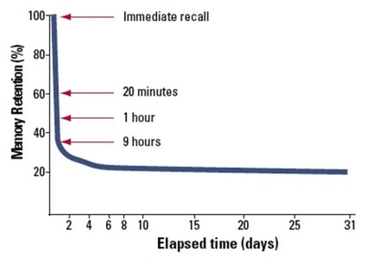
- Forgetting curve: recall decreases rapidly at first, then reaches a plateau after which little more is forgotten (EBBINGHAUS)
- Proactive interference: old info blocks new
- Retroactive interference: new info blocks old
- Misinformation effect: distortion of memory by suggestion or misinformation (Loftus – lost in the mall, Disney land)
- Anterograde amnesia: amnesia moves forward (forget new info – 50 first dates)
- Retrograde amnesia: amnesia moves backwards (forget old info)
- Alzheimer’s Disease: caused by destruction of acetylcholine in hippocampus
LANGUAGE
- Phonemes: smallest unit of sound (ch sound in chat)
- Morpheme: smallest unit that caries meaning (syllable)
- Grammar: rules in a language that enable us to communicate
- Semantics: set of rules by which we derive meaning (adding –ed makes something past tense)
- Syntax: rules for combining words into sentences (white house vs casa blanca)
- Babbling stage: infants babble 1st stage of speech
- One-word stage: duh
- Two-word stage: duh duh
- Theories of language development:
  - Imitation: Kids repeat what they hear – but they don’t do it perfectly
    - Overregularization: grammar mistake where children over use certain morphemes (I go-ed to the park)
  - Operant conditioning: reinforced for language use
  - Inborn universal grammar: theory comes from NOAM CHOMSKY – says that language is innate and we are predisposed to learn it
  - Critical period: period of time where something must be learned or else it cannot ever happen (language must be learned young – Genie the Wild Child)
  - Linguistic determinism: language influences the way we think (Hopi people do not have words for the past, thus cannot easily think about the past) developed by WHORF
THINKING
- Concepts: mental categories used to group objects, events, characteristics
- Prototypes: all instances of a concept are compared to an ideal example (what you first think of)
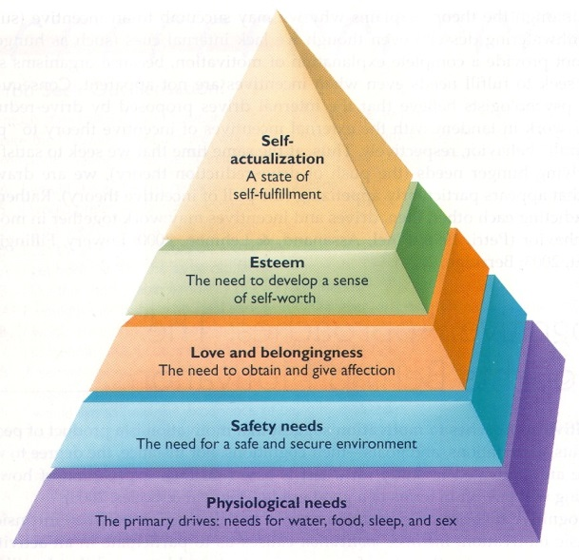
- Algorithms: step by step strategies that guarantee a solution (formula)
- Heuristics: short cut strategy (rule of thumb)
  - Representative Heuristic: make inferences based on your experience (like a stereotype) – assume someone must be a librarian b/c they’re quiet
  - Availability heuristic: relying on availability to judge the frequency of something (over estimating death due to plane crashes due to recent events)
- Functional Fixedness: keep using one strategy – cannot think outside of the box
- Belief bias: tendency of one’s preexisting beliefs to distort logical reasoning by making invalid conclusions
- Belief perseverance: tendency to cling to our beliefs in the face on contrary evidence
- Inductive reasoning: data driven decisions, general specific
- Deductive reasoning: driven by logic, specific general
- Divergent thinking: ability to think about many different things at once

Motivation & Emotion
(6-8%)
THEORIES OF MOTIVATION
- INSTINCT: complex behaviors have fixed patterns and are not learned (explains animal motivation)
- DRIVE REDUCTION: physiological need creates aroused tension (drive) that motivates you to satisfy the need (driven by homeostasis: equilibrium)
  - Primary drive: unlearned drive based on survival (hunger, thirst)
  - Secondary drive: learned drive (wealth or success)
- OPTIMUM AROUSAL: humans aim to seek optimum levels of arousal –easier tasks requires more arousal, harder tasks need less
- HIERARCHY OF NEEDS: theory derived by MASLOW – needs lower in the pyramid have priority over needs higher in the pyramid

- Intrinsic motivation: inner motivation – you do it b/c you like it
- Extrinsic motivation: motivation to obtain a reward (trophy)

HUNGER
- Signals of hunger:
  - Stomach contractions tell us we’re hungry
  - Glucose (sugar) level is maintained by the pancreas (endocrine system).
  - Insulin decreases glucose. Too little glucose makes us hungry.
  - Orexin is released by the hypothalamus – telling us to eat.
  - Other chemicals include ghrelin, obestatin, and PPY
  - Lateral hypothalamus: when stimulated makes you hungry, when lesioned you will never eat again. (I’m LATE for lunch. I’m hungry. The LATEral hypothalamus makes you hungry.)
  - Ventromedial hypothalamus: when stimulated you feel full, when destroyed you eat eat eat eat (fat woman and cake)
  - Leptin: leptin signals the brain to reduce appetite
- Obesity:
  - Increased risk of heart attack, hypertension, atherosclerosis, diabetes
  - Can be genetic – adopted children resemble their biological parents
  - Set point: there is a control system that dictates how much fat you should carry – every person is different
- Eating Disorders:
  - Anorexia: weight loss of at least 15% ideal weight, distorted body image
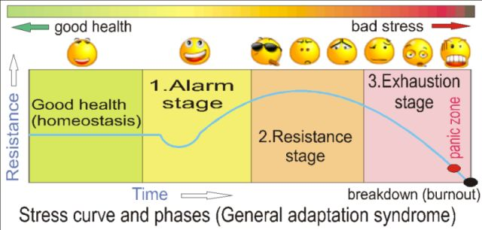
    - Causes: overly critical parents, perfectionist tendencies, societal ideals
  - Bulimia: usually normal body weight, go through a binge-purge eating pattern (eat massive amounts, then throw up)
    - Causes: same as anorexia
SEXUALITY
- Biology of sex:
  - Hypothalamus: stimulation increases sexual behavior, destruction leads to sexual inhibition
  - Pituitary gland: monitors, initiates, and restricts hormones
    - Males – testosterone
    - Females - estrogen
  - Sexual Response Pattern: Excitement phase, plateau, orgasm, refractory period (resolution phase) (cannot “fire” again until you reset, guys only)
  - Alfred Kinsey: 1st researcher to conduct studies in sex, suggested that people were very promiscuous. Studies lacked a representative sample, created scale of homosexuality
  - Homosexuality: biological roots: differences in the brain, identical twins more likely to both be gay, later sons more likely to be (hormones from mom)

THORIES OF EMOTIONS
- JAMES-LANGE: stimulus physiological arousal emotion
- CANNON-BARD: stimulus physiological arousal & emotion simultaneously
- SCHACTER TWO FACTOR: adds in cognitive labeling (bridge experiment) stimulus arousal interpret external cues label emotion
- Some stimuli are routed directly to the amygdala bypassing the frontal cortex (gut reaction to a cockroach)
- Behavioral factors: there are SIX universal emotions (happiness, anger, sadness, surprise, disgust, feat) seen across ALL cultures
- Non-verbal cues: gestures, duchenne smile (you can tell a real smile from a fake one)
- Facial feedback hypothesis: being forced to smile will make you happier (facial expressions influence emotion)
STRESS AND HEALTH
- GENERAL ADAPTATION SYNDROME (GAS): three phases of a stress response (SELYE came up w/ this)
  - Alarm: body/you freak out in response to stress
  - Resistance: body/you are dealing with stress
  - Exhaustion: body/you cannot take any more, give up

- Type A Personality: rigid, stressful person, perfectionist. At risk for heart disease
- Type B Personality: laid back, nonstressed.
INDUSTRIAL/ORGANIZATIONAL PSYCH
- Industrial / Organizational Psych: psychological of the workplace – focuses on employee recruitment, placement, training, satisfaction, productivity
- Ergonomics / Human Factors: intersection of engineering and psych – focuses on safety and efficiency of human-machine interactions
- Hawthorne effect: productivity increases when workers are made to feel important
- Theory X management: manager controls employees, enforces rules. Good for lower level jobs
- Theory Y management: manger gives employees responsibility, looks for input. Good for high level jobs

- Employee Commitment:
  - Affective: emotional attachment (best type)
  - Continuance: stay due to costs of leaving
  - Normative: stay due to obligation (they paid for your school)
- Meaning of Work:
  - Job – no training, just do it for $$. No happiness
  - Career – work for advancement. Some happiness
  - Calling – work because you love it. Lotsa happiness
Development
(7-9%)
- Prenatal Development:
  - Zygote: 0 – 14 days, cells are dividing
  - Embryo: until about 9 weeks, vital organs being formed
  - Fetus: 9 wks to birth, overall development
  - Teratogens: external agents that can cause abnormal prenatal development (alcohol, drugs, etc)
    - Fetal alcohol syndrome (FAS): large amount of alcohol leads to FAS, causes deformities, mental retardation, death
- Physical Development:
  - Maturation: natural course of development, occurs no matter what (walking)
  - Reflexes: innate responses we’re born with
    - Rooting, sucking, swallowing, grasping, stepping
  - Habituation: after continual exposure you pay less attention – used to test babies
  - Eyes have the most limited development, takes till 1 year
    - Visual cliff: babies have to learn depth perception, so they will cross a “cliff”
  - Other senses are fairly developed
  - Brain development continues for a few years
- JEAN PIAGET’S COGNITIVE DEV.
- Schemas – concepts or frameworks that organize info
- Assimilation: incorporate new info into existing schema (aSSimlation – same stuff)
- Accommodation: adjust existing schemas to incorporate new information (ACcommodation - All Change)
- Sensorimotor Stage: Birth to 2 years: focused on exploring the world around them
  - Lack Object Permanence: Objects when removed from field of view are thought to disappear (peek-a-boo)
  - Dev. Sense of Self: by 2 yrs can recognize themselves in the mirror

- Pre-operational Stage: 2 – 7 years: use pretend play, developing language, using intuitive reasoning
  - Lack Conservation: recognize that substances remain the same despite changes in shape, length, or position (girls with juice in glasses)
  - Lack Reversibility: cannot do reverse operations (count out both 4+2 and 2+4)
  - Are egocentric: inability to distinguish one’s own perspective from another’s – think everyone sees what they see
- Concrete Operational Stage: 7-11 yrs: use operational thinking, classification, and can think logical in concrete context
- Formal Operational Stage: 11-15 yrs: use abstract and idealist thoughts, hypothetical-deductive reasoning
- Problems with Piaget’s theory: stages to discrete, dev. differs b/w kids
- VYGOTSKY’S THEORY: cognitive development is a social process too, need to interact w/ others
  - Zone of Proximal Development: gap b/w what a child can do on their own and w/ support. Need scaffolding (teachers)
SOCIOEMOTIONAL DEVELOPMENT
- Temperament: patterns of emotional reactions and babies (precursor to personality)
- Imprinting: baby geese believe the first thing they see after hatching is their mom – happens during a critical period (from LORENZ)
- HARRY HARLOW: discovered that contact comfort is more important than feeding (monkeys fed on wire or cloth mothers). Monkeys raised in isolation couldn’t socialize
- MARY AINSWORTH: developed the strange situation paradigm (children left alone in a room w/ a stranger, then reunited w/ mom – determines your attachment style
  - Secure attachment (60% of infants): upset when mom leaves, easily calmed on return. Tend to be more stable adults
  - Avoidant attachment (20% infants): actively avoids mom, doesn’t care when she leaves
  - Ambivalent attachment(10% infants): actively avoids mom, freaks out when she leaves
  - Disorganized attachment (5%): confused, fearful, dazed – result of abuse
- BAUMRIND: parenting styles
  - Authoritarian: rules & obedience, “my way or the highway” – kids lack initiative in college
  - Permissive: kids do whatever – no rules – kids lack initiative in college
  - Authoritative: give and take w/ kids – kids become socially competent and reliable
- KOHLBERG’S MORAL DEV
  - Preconventional morality: Children: they follow rules to avoid punishment
  - Conventional morality: adolescents: follow rules b/c rules exist to keep order
  - Postconventional morality: adults: they do what they believe is right (even if it goes against society)
- Carol Gilligan: said moral reasoning and moral behaviors are two different things (what you say isn’t always what you do)
- ERIKSON’S SOCIOEMOTINAL DEV. : 8 stages, each stage represents a crisis that must be resolved, results in competence or weakness
  - Trust vs Mistrust (birth – 18 months): if needs are dependably met infants dev basic trust
  - Autonomy vs shame&doubt (1 -3 yrs): toddlers learn to exercise their will and think for themselves
  - Initiative vs guilt (3-6 yrs): learn to initiate tasks and carry out plans
  - Industry vs inferiority (6 yrs to puberty): learn the pleasure of applying themselves to tasks
  - Identity vs role confusion: (adolescence thru 20s): refine a sense of self by testing roles and forming an identity
  - Intimacy vs isolation: (20s—40s): form close relationships and gain capacity for love
  - Generativity vs stagnation: (40s-60s): discover sense of contributing to the world, thru family & work
  - Integrity vs despair: (60s and up): reflect on your life, feel satisfaction or failure
- Puberty! (rapid skeletal and sexual maturation)
  - Primary sex characteristics: necessary structures for reproduction (ovaries, testicles, vagina, penis)
  - Secondary sex characteristics: nonreproductive characteristics that dev during puberty (breasts, hips, deepening of voice, body hair)
  - Frontal lobe continuous dev (not fully developed till 25)
- Gender Development: sex = chromosomes, gender = what you identify yourself as
  - Gender roles: expected behaviors (norms) for men/women
  - Social learning theory: we learn gender roles and identity from those around us
- Aging:
  - Cellular clock theory: cells have a maximum # of divisions before they can’t divide anymore
  - Free-radical theory: unstable oxygen molecules w/in cells damage DNA
  - Over time skills decrease (reaction time, memory)
- Cross-sectional study: studies ppl of different ages at the same point in time
  - Adv: inexpensive & quick
  - Disadv: can be differences due to generational gap
- Longitudinal study: studies same ppl over time
  - Adv: eliminates groups differences, lots of detail
  - Disadv: expensive, time consuming, high drop out rates
- Stages of Grief (crap btw)
  - Denial: “this can’t be happening”
  - Anger: “why me?”
  - Bargaining: “just let me live to see my kids graduate”
  - Depression: “why bother”
  - Acceptance: “its going to okay”
- Problem-focused coping: solving or doing something to alter the course of stress (planning, acceptance)
- Emotion-focused coping: reducing the emotional distress (denial, disengagement)
Personality
(5-7%)
PSYCHODYNAMIC EXPLANATION
Sigmund Freud said personality was largely unconscious. Came up w/ the following:
- Conscious: immediate awareness of current environment
- Preconscious: available to awareness (phone #s)
- Unconscious: unavailable to awareness
- id: our hidden true animalistic wants and desires – operates on the pleasure principle, all about rewards and avoiding pain (devil on your shoulder – entirely unconscious)
- superego: our moral conscious (angel on your shoulder, all 3 consciousness)
- ego: reality principle, has to deal w/ society, stuck mediating b/w the id and superego (its you! – conscious and preconscious)
When ego cannot mediate b/w the id and superego, we use defense mechanisms
- Repression: push memories back into the unconscious mind (sexual abuse is too traumatic to deal w/ so you repress it)
- Projection: attribute personal shortcomings & faults on to others (man who wants to have an affair accuses his wife of having one)
- Denial: refuse to acknowledge reality (refuse to believe you have cancer)
- Displacement; shift feelings from an unacceptable object to a more acceptable one (can’t tell at teacher, go home and yell at the dog)

- Reaction formation: transform unacceptable motive into his opposite (woman who fears sexual urges becomes a religious zealot)
- Regression: transform into an earlier development period in the face of stress (during exam week you start to suck your thumb)
- Rationalization: replace a less acceptable reasoning with a more acceptable one (don’t get into your college – justify it was a sucky college anyway)
- Sublimination: replace unacceptable impulse w/ a socially acceptable one (man w/ strong sexual urges paints nudes. Dexter)
FREUD’S PSYCHOSEXUAL STAGES
- Oral stage (0-18 months): pleasure focuses on the mouth (id)
- Anal stage (18 – 36 months): pleasure involves eliminative functions (ego forms)
- Phallic stage (3 – 6 yrs): pleasure focuses on genitals (superego forms)
  - Oedipal complex: young boys learn to identify w/ their father out of fear of retribution (castration anxiety)
  - Electra complex: young girls learn to identify w/ their mother b/c they cannot with their father (penis envy)
- Latency stage (6 yrs to puberty): psychic time out – personality is set
- Genital State (adulthood): sexual reawakening – oedipal and electra “feelings” are repressed, turn sexual wants onto an appropriate person
- FIXATION: can become “stuck” in an earlier stage – influences personality (oral stage smokes/drinks, anal is “anal retentive”, phallic is promiscuous)
What’s wrong w/ Freud theory? – unverifiable, descriptive not predictive
What’s good about it? – 1st theory about personality, sparked psychoanalysis
How do we test this approach?
- Psychoanalysis: analyze a person’s unconscious motives thru the use of:
  - Free Association: say aloud everythying that comes to mind w/o hesitation
  - Transference: looks for feelings to transferred to psychoanalyst
  - Dream interpretation: analyze the manifest (seen message) and latent (hidden messages) content
  - Projective Tests: ambiguous stimuli shown to look at your unconscious motives (THESE SUCK B/C THEY ARE VERY SUBJECTIVE)
    - Thematic apperception test (TAT) : tell a story about a picture (when someone has a tattoo (tatt) you ask what it means
    - Rorschach inkblot: show an inkblot

NEO-FREUDIANS
- CARL JUNG: believed in the collective unconconcious (shared inherited reservoir of memory – explains common myths across civilizations & time)
- KAREN HORNEY: said personality develops in context of social relationships, NOT sexual urges (security not sex is motivation, men get womb envy)
TRAIT PERSPECTIVE
- Traits are enduring personality characteristics, people can be described by these – have strong or weak tendencies. They are stable, genetic, and predict other attributes.
- Use factor analysis to find these: statistical procedure used to identify similar components
- TRAIT THEORIES:
- Big Five: (by Costa & McCrae) (acronym OCEAN) You vary on each of these
  - Openness : imaginative, independent, like variety
  - Conscientiousness: organized, careful, disciplined
  - Extraversion: sociable, fun-loving, affectionate (opoosite it introversion: shy, timid, reserved)
  - Agreeableness: soft hearted, trusting, helpful
  - Neuroticism (emotional stability): calm, secure
What’s wrong with trait theory? – ignores the role of the situation in behavior
What’s good about it? - identifying traits gives us perspectives about careers, relationships, health
How do we test this approach?
- MMPI – helpful for mental health and job placement
- Myer’s Briggs – gave you 4 letter combo
What’s wrong w/ these tests?
- They’re long, social desirability can be an influence, and they’re too broad
HUMANISTIC PERSPECTIVE
- Emphasized personal growth and free will. You don’t like yourself? So change!
- CARL ROGERS: talked about our self-concept (idea of who we are). Your self-concept is the center of your personality
  - Actual (social) self: what others see
  - Ideal (true) self: who you WANT to be
  - A positive self-concept makes us perceive the world positively (optimist)
  - A negative self-concept makes us feel dissatisfied and unhappy
What wrong with humanistic theory? - too optimistic about human nature, abstract concepts are difficult to test
What’s good about it? – emphasizes conscious experiences and change

- Individualistic Cultures: give priorities to own goals over group goals. Define your identify in terms of you (American society)
- Collectivistic Cultures: give priority to the goals of the group, your identity is part of that group (China)
SOCIAL-COGNITIVE PERSPECTIVE
- Behavior is a complex interaction of inner process and environmental influence – which influences personality
- Emphasizes conscious awareness, beliefs, expectations, and goals
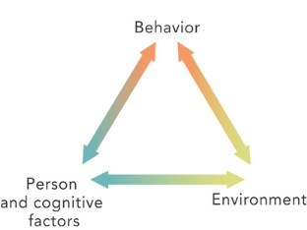
- BANDURA! Talked about RECIPROCAL DETERMINISM: interaction of behavior, cognitions, and environment make up you.

{I’m outgoing (behavior), I choose to teach b/c it lets me be outgoing (environment), and I have thought this through which is why I teach despite making less money (cognitive)}
- Self-efficacy: belief that one can succeed, so you ensure you do
- Internal locus of control: you control your own fate
- External locus of control: chance / outside forces control your fate
What’s wrong with social-cognitive? – Too specific, cannot generalize
What’s good about it? – Highlights situations, and cognitive explanations of personality
How do we test it? – Observations & interviews (time consuming)
Testing &
Individual Differences
(5-7%)
Individual Theories about Intelligence
- GALTON: 1st to suggest intelligence was inherited. Intelligence based on muscle strength, size of head, reaction time, etc.
- CATTELL: 2 clusters of mental abilities
  - Crystalized intelligence: reasoning and verbal skills - what you learn in school – the cold hard (like crystals!) facts
  - Fluid intelligence: spatial abilities, rote memory, things that come natural to you – can’t learn in school. Also decrease over time
- SPEARMAN’S G FACTOR: said a general intelligence (g) underlies all mental abilities (typical IQ of today)
- GARDNER: multiple intelligences (8): linguistic, logical-mathematical, musical, spatial, bodily-kinesthetic, intrapersonal (self), interpersonal (social), naturalist

- STERNBERG: TRIARCHIC THEORY
  - Analytical: mental components to solve problems, what IQ tests assess (book smarts)
  - Practical: ability to size up new situations and adapt to real-life demands (street smarts)
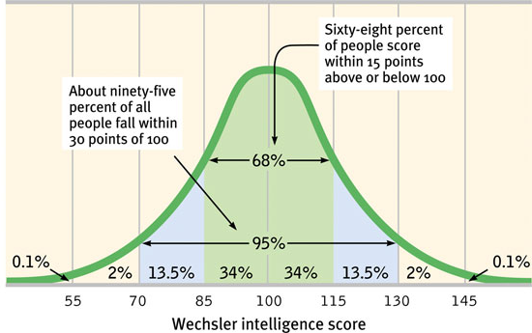
  - Creative: intellectual and motivational processes that lead to novel solutions, idea, products
- BINET: developed 1st intelligence test, combined with TERMAN – developed the STANFORD-BINET IQ TEST
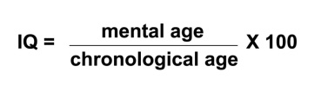
  - Chronological age = actual age
  - Mental age = tested age compared to other of that age
  - 100 is average
- WECHSLER: developed the WAIS and WISC – most commonly used today
- FLYNN effect: IQ has steadily risen over the past 80 years – probably due to education standards and better IQ tests
- Extremes of Intelligence: high IQ = above 135; mentally retarded = below 70
- Causes of mild retardation:
  - PKU – liver fails to produce an ezyme needed to breakdown chemicals – leads to brain damage
  - Down syndrome – extra copy of 21st chromosome
  - Fragile X – higher chance in boys due to ONE X chromosome
- Influence on IQ:
  - Genetics: MZ twins have similar IQ, adopted kids more similar to biological parents
  - Environment: early neglect leads to lower IQ, good schooling to higher IQ
- Types of Tests:
  - Aptitude: predicts your abilities to learn a new skill (ASVAB)
  - Achievement: tests what you know(SAT)
- TEST CREATION:
  - Standardization: administer a test to a representative sample of future test takers to establish a basis for meaningful comparison (test it out 1st)
  - Should be reliable: same results over time
    - Split-half reliability: compare two halves of the test
    - Test-retest reliability: use the same test on 2 different occasions
  - Should be valid: test is accurate – measures what it is intended to
    - Content validity: test measures what you want it to (an IQ test actually measures IQ)
    - Predictive validity: test is able to accurately predict a trait (high math scores predicts good engineer)
- Standardized tests establish a normal distribution
- Standard deviations are used to compare scores.
- Standard deviation measures how much the scores vary from the mean. The percentages stay the same in every curve

Abnormal Behavior
(7 – 9%)
- Defining abnormal behavior:
  - Must be deviant, distressful, and dysfunctional
- Historical causes: biology, psychological issues, supernatural issues (demons)
- Medical model: emphasizes treatment of disorders, as they have a biological origin. Came through the reformation of institutions in U.S. (DORTHEA DIX)
- Biopsychosocial model: currently used model – stress biological, psychological, and social causes
- Diagnosing abnormal behavior:
  - DSM: manual listing all currently accepted psychological disorders. Classifies them based on criteria – provides no explanation of causes or treatments
ANXIETY DISORDERS
Most common disorders in the U.S.
- Generalized Anxiety Disorder (GAD): person is generally anxious, all the time, for NO REASON
- Panic Disorder: person is prone to frequent panic attacks (feeling like you’re having a heart attack). Can come w/ agoraphobia: anxiety about being in places you cannot escape (fear of public spaces / people)
- Phobias: irrational fear that disrupts your life
- Obsessive-compulsive Disorder (OCD): person if overwhelmed with both:
  - Obsessions: persistent unwanted thoughts (did I leave the stove on?)
  - Compulsions: senseless rituals (hand washing)
- Post-traumatic stress disorder (PTSD): characterized by flashbacks, problems w/ concentration, and anxiety following a traumatic event (war, natural disasters)
CAUSES OF ANXIETY DISORDERS:
- Psychodynamic: repressed thoughts & feelings manifest in anxiety and rituals
- Behaviorist: fear conditioning leads to anxiety, which is then reinforced. Phobias might be learned through observational learning
- Biological: natural selection favored those with certain phobias (heights). Twins often share disorders. Often see less GABA in the brain
SOMATOFORM DISORDERS
- Psychological disorders w/ no apparent physical cause
  - Conversion disorder: loss of feeling or usage of a limb or body part (sight) – absolutely no physiological cause though
  - Hypochondriasis: person interprets normal symptoms as a major disease – must disrupt their life
DISSOCIATIVE DISORDERS
- Dissociative Identity Disorder: formerly multiple personalities – person fractures into several distinct personalities who normally have no awareness of each other. NOT SCHIZOPHRENIA!
  - Usually caused by traumatic childhood abuse
  - Legitimacy is doubted by some, more common in those w/ good health insurance
  - Treatment involves integration of the personalities
- Dissociative Fugue: following a traumatic event a person leaves, taking on a whole new life & personality w/ no memory of the previous one
MOOD DISORDERS
- Major depressive disorder: extreme sadness and despair, apathy towards life, w/ no known cause
- Dysthymia: milder form of depression, lasts for years (Eeyore!)
- Bipolar disorder: bouts of severe depression & manic episodes
  - Mania: heightened mood, characterized by risky behaviors, fast talking, flights of ideas
- Seasonal Affective Disorder (SAD): form of depression that occurs typically winter – found mostly in Northern areas (Alaska, Ireland) UNIQUE TREATMENT = LIGHT THERAPY
CAUSES OF MOOD DISORDERS
- Biology: lower levels of serotonin & norepinephrine linked to depression, higher levels of norepinephrine linked to mania. Runs in families suggesting GENES. Twin studies also support this.
- Cognitive: negative thought patterns leads to depression

SCHIZOPHRENIA
NOT MULTIPLE PERSONALITIES! THEY HAVE ONE PERSONALITY!
- SYMPTOMS
  - Positive Symptoms (not good – means something added))
    - Hallucinations: sensory experiences w/o sensory stimulation (seeing and/or hearing things)
    - Delusions: fixed, false beliefs (people are out to get them, grandiose thoughts (I am God)
    - Disorganized thinking
    - Disorganized speech
  - Negative Symptoms (something taken away)
    - Flat affect: lack ability to show emotions
    - Impaired decision making, inability to pay attention
  - Catatonia: become frozen over periods of time (exhibit waxy flexibility: can move them into new positions)
- CAUSES OF SCHIZOPHRENIA
  - Brain abnormalities: enlarged ventricles (atrophy), smaller frontal cortex
  - Genetics: runs in families, MZ twins at higher risk
  - Dopamine hypothesis: too much dopamine in the brain
  - Diathesis – Stress: individual has a genetic predisposition, disease must be “turned-on” by environmental stimuli (like stress) – explains why it is most commonly developed during college years
PERSONALITY DISORDERS
- Marked by disruptive, inflexible, enduring behavior patterns – makes this very difficult to treat!
  - Antisocial: NOT “avoidant of socialization” – more like “anti-society” – disregard for others, manipulative, breaks laws
  - Borderline: instable interpersonal relationships & self-image, “I hate you, don’t leave me”
  - Histrionic: excessive emotionality & attention seeking (slut disorder)
  - Narcissistic: need for admiration & lack of empathy (who cares about everyone else – look at me!)

Treatment of Psychological Disorders (5-7%)
- PSYCHODYNAMIC APPROACH: SEE PERSONALITY SECTION
- HUMANISTIC APPROACH:
  - Client-centered therapy: (developed by CARL ROGERS) techniques include active listening, accepting environment, focuses on patient growth (you figure out what needs to change and do it)
- COGNITIVE APPROACH:
  - Rational-emotive therapy: (developed by ELLIS) techniques include analyzing self-defeating behaviors to change thought patterns – and then change behaviors associated w/ said patterns
    - Best for anxiety disorders
    - Very confrontational
  - Cognitive therapy: (developed by BECK) illogical thoughts psychological problems, challenges those thoughts
    - Best for depression
    - Self-directed – you figure out your errors
- BEHAVIORAL APPROACH (typically used for anxiety disorders / phobias)
  - Classical Conditioning:
    - Counterconditioning Little Albert & Watson
      - Aversive conditioning: associate an unpleasant experience (e.g. nausea) w/ an unwanted behavior (e.g. drinking alcohol)
    - Exposure therapy: slowly expose people to whatever it is that makes them anxious
      - Systematic desensitization: associate a pleasant relaxed state w/ gradually increasing anxiety triggering stimuli (create a desensitization hierarchy – ex. List of things about flying that makes you nervous – step through each one till you can do it)
      - Intensive exposure therapy (Flooding): force someone to experience the fear (afraid of drowning, throw you in a pool)
  - Operant Conditioning: use behavior modification (reward good behaviors w/ token reinforcers ). Used in schools, w/ autistic children, etc.
- OTHER THERPAIES:
  - Family therapy: treats the family as a system, individual behaviors are influenced by family dynamics
  - Group therapy: therapy through a group – lets patients see “they’re not alone”

- BIOLOGICAL APPROACH: CALLED BIOMEDICAL THERAPIES
  - Drug therapies (psychopharmacology):
    - Anti-psychotics: decrease dopamine: treats schizophrenia
      - Side effects: TARDIVE DYSKINESIA: hand tremors (similar to Parkinson’s- due to lack of dopamine), worsening of negative symptoms, extreme sedation
      - Drug names: thorazine, clozapine
    - Anti-depressants: increase serotonin through REUPTAKE inhibition
      - Side effects: drowsiness, anxiety, can increase suicide risk in teens
      - Drug names: SSRIs (selective serotonin reuptake inhibitors) like Prozac, Zoloft, Paxil. SNRIs (selective norepinephrine reuptake inhibitors) Cymbalta, Effexor
    - Mood stabilizers: used in the treatment of BIPOLAR disorder : LITHIUM
    - Anti-anxiety drugs: depress the central nervous system (dangerous in combo w/ alcohol) Xanax, Ativan
  - Electroconvulsive therapy (ECT): send electricity into the brain to induce minor seizures. Used (rarely) to treat depression (when nothing else works). Thought to “reboot” the brain
  - Psychosurgery (frontal lobotomy): frontal lobe is surgically destroyed. Used to treat depression or violent individuals – almost never used anymore
Social
(8-10%)
SOCIAL THINKING
- Attribution theory: we explain others behaviors by crediting the situation or the person’s disposition (they only passed b/c they cheated)
- Fundamental attribution error (very similar to Actor-observer bias): tendency for observers to underestimate the importance of the situation and overestimate the impact of personal disposition (that guy cut me off b/c he’s a jerk – not that his wife could be in labor)
ATTITUDES AND ACTIONS
- Central route to persuasion: change people’s attitudes through logical arguments and explanations. Leads to long term behavior change
- Peripheral route to persuasion: change people’s attitudes through incidental cues (like a speaker’s attractiveness). Leads to temporary behavior changes
- Foot in the door phenomenon: complying w/ a small request then leads to going along w/ a larger request (can I have $5? Yes. Now can I have $25?)
- Door in the face phenomenon: a large request is turned down, when then leads you to be more likely to comply w/ a small request (can I have $100? Heck no! How about $20? Okay)
- STANFORD PRISON EXPERIMENT (ZIMBARDO): classic “experiment” where individuals were assigned to be guards / prisoners. w/in days they took on their roles and went too far. Highly unethical
- Cognitive dissonance (FESTINGER): two opposing thoughts conflict w/ each other, causing discomfort (dissonance), which makes us find ways to justify the situation (cult that was going to be abducted by aliens, smokers)
SOCIAL INFLUENCE
- Conformity: classic experiment done by ASCH – showed lines of different lengths, confederates gave wrong answers to see if others would go along w/ it
  - Normative social influence: we conform to gain approval or to not stand out from the group (be part of the norm
  - Informational social influence: we conform to others b/c we think their opinions must be right
- Obedience: classic experiment done by MILGRAM: participants were to “teach” another individual using shocks. 60% of participants would administer lethal shocks to another person simply b/c they were told to
GROUP INFLUENCE
- Social facilitation: perform better on simple or well learned tasks in the presence of others
- Social loafing: tendency for ppl in a group to exert less effort when pooling their effort together (tug of war)
- Deindividuation: loss of self-awareness and self-restraint occurring in group situations that foster arousal and anonymity (mob mentality)
- Group polarization: the more time spent w/ a group the more similar (polarized) their thoughts / opinions will become
- Groupthink: desire for harmony w/in a group leads to everyone going along w/ the same thinking, ignoring other possibilities or bad ideas
- Risky shift: groups make riskier decisions together rather than alone
PREJUDICE
- Ingroup: “US” – ppl w/ whom we share a common identity
- Outgroup: “them” – ppl perceived as different or not part of the group
- Ingroup bias: tendency to favor our own group
- Scapegoat theory: prejudice offers an outlet for anger by providing someone else to blame
- Ethnocentrism: tendency to see your own group as more important than others
- Just-world phenomenon: tendency for ppl to believe that the world is just and therefore ppl get what they deserve (homeless ppl)
AGGRESION
- Genetic influence: runs in families, can breed for in animals
- Lower serotonin, higher testosterone
- Environmental influence: social learning theory (BANDURA) – observing violence in others makes us more violent for a time
  - Also: pollution, crowding, heat, humidity
- Frustration-aggression hypothesis: frustration creates anger, which leads to aggression
ATTRACTION
- Mere exposure effect: repeated exposure to novel stimuli increases liking of them (the more time you spend around something the more you like it)
- Physical attractiveness: pretty ppl are thought to be more credible, less likely to do bad things
- Similarity: we prefer ppl similar to us
ALTRUISM
- Altruism: unselfish regard for the welfare of others
- Bystander effect: the more ppl around the less likely we are to help someone in need
- Social exchange theory: social behavior (helping) is an exchange process – aim is to maximize benefits and minimize cost
- Reciprocity norm: we give so we can get
CONFLICT
- Social trap: conflicting parties pursue their own best interests, which can result in destructive results (prisoner’s dilemma – game theory)
- 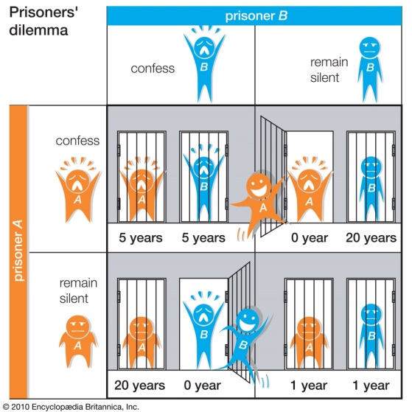

- Approach approach conflict: win – win situation; conflict is which win you have to choose (you can eat out at ONE of your two favorite restaurants – you can only choose one though)
- Approach avoidance conflict: win – lose situation; outcome has positive and negative aspects (marriage)
- Avoidance avoidance conflict : lose – lose; both outcomes are bad but you have to choose one (clean your room or do your homework)
- Multiple approach avoidance conflict: two (or more) win-lose situations; conflict is which to choose (College A is good for your major but no scholarship, College B is bad for your major but has a scholarship)
SOCIAL SELF
- Self-concept bias: what we consider important in ourselves is what we consider important in others
- False-consensus effect: we overestimate the degree to which everyone else thinks / acts the way we do
- Self-fulfilling prophecy: a belief that leads to its own fulfillment (I expect you all to pass, you know this, you study – fulfilling my prophecy)
- Self-serving bias: readiness to perceive ourselves as favorably
- Spotlight effect (self-objectification) : tendency of an individual to overestimate the extent to which others are paying attention to them
MULTIPLE CHOICE STRATEGIES
- Bubble as you go – you don’t want to run out of time!
- Answer EVERY QUESTION – you don’t lose points for guessing
  - If you run out of time pick either B, C, or D and bubble straight down. DO NOT ZIG ZAG
- If you don’t recognize an answer choice – it probably IS NOT THE ANSWER
ESSAY WRITING STRATEGIES
ANSWER THE STUPID QUESTION!
- Don’t write in bullet points!
  - No Fluff – no transitions – no topic / thesis statements
- Be specific and apply the answer to the prompt
Created by C.Thompson; 2013
Colleen.thompson@fortbendisd.com

